Software Design Document
Smart Library Management System



Submitted by
<AREE BA (S23BINFT1M01080)>

Submitted to
<Prof. Dr Dost Muhammad Khan>

Department of Information Technology
Faculty of Computing
The Islamia University of Bahawalpur

Summery
This is a Software Design Document (SDD) where all the design aspects of the Library Management System (LMS) that will be used at The Islamia University Bahawalpur have been detailed out. This Library Management System (LMS) transforms the library manual processes to a sophisticated system using the internet. It will make it very convenient for everyone who uses the library, including the students, teachers, and librarian. The system automates core library operations:
- Book management (add, edit, delete, search)
- Member management (registration, renewal, deletion)
- Borrowing and returning books with due date calculation
- Automatic fine calculation ($0.50/day overdue)
- Role-based access control (Admin, Librarian, Member)
- Responsive UI for desktop and tablet

The design follows the Model-View-Controller (MVC) architectural design pattern. In addition, it applies HTML, Bootstrap 5, PHP, and MySQL programming languages. The design has an interface that is very friendly, security features that include authentications and proper data management system. This software design document highlights the system architecture, database design, and user interface design including screens, control panels, and codes. This new system will ease the process a lot.

Table of Contents
1. Application Architecture 3
1.1 Overall Architecture (MVC Pattern) 4
1.2 Models 4
1.3 Views 4
1.4 Controllers 5
1.5 Class Diagram 6
1.6 Sequence Diagram 7
1.6.1 Sequence Diagram for Sign Up 8
1.6.2 Login Sequence Diagram 8
1.6.3 Search Book Sequence Diagram 9
1.6.4 Issue Book Sequence Diagram 10
1.6.5 Return Book Sequence Diagram 11
1.6.6 Add new Book Sequence Diagram 12
1.7 Coding Conventions 13
2. Data Model Schema 15
2.1 Introduction to Database Design 15
2.2 Database Normalization 15
2.3.1 First Normal Form: 15
2.3.2 Second Normal Form: 16
2.3.3 Third Normal Form: 16
2.4 Entities and Attributes 17
2.1.1 Users Table 17
2.1.2 Books Table 18
2.1.3 Issued_Books Table 18
2.1.4 Reservations Table 19
2.1.5 Fines Table 19
2.5 Entity Relationships 20
2.6 ER Diagram 21
3 User Interface 22
3.1 Design Philosophy 22
3.2 List of Screens/Pages 22
3.3 Screen-wise Design Details 23
3.3.1 Login Page 23
3.3.2 User Registration 28
3.3.3 User Dashboard 37
3.3.4 Book Search & Browse 47
3.3.5 Book Details Page 48
3.3.6 Issue Book Page 49
3.3.7 Return Book Page 64
3.3.8 Manage Books (Admin) 78
3.3.9 My Borrowed Books 85
3.3.10 Defaulter List & Reports 92

- Application Architecture

Overall Architecture (MVC Pattern)
The MVC (Model-View-Controller) design pattern forms the foundation for organizing various elements within the Library Management System, making it easily maintainable, scalable, and reusable.
Model: Holds all the business logic and database-related operations.
View: Deals with presentation logic and rendering the view layer.
Controller: Acts as a bridge between Model and View layers and processes user events.
This pattern is implemented using PHP as the backend, Bootstrap 5 for responsive frontend, and MySQL as the database.

Models
The system includes the following models (each model corresponds to a database table):
- UserModel
- BookModel
- IssuedBookModel
- FineModel
- ReservationModel
- ReportModel
Each model contains methods for CRUD (Create, Read, Update, Delete) operations.

Views
All views are created using HTML5, CSS3, JavaScript, and Bootstrap 5. Key views include:
- login.php
- dashboard.php
- book_search.php
- issue_book.php
- return_book.php
- add_book.php (admin only)
- manage_users.php (admin only)
Views are kept separate from business logic for clean separation of concerns.

Controllers
Controllers handle all user requests and business logic. Major controllers and their functions are:
UserController
- registerUser()
- loginUser()
- logoutUser()
- updateProfile()
BookController
- searchBook()
- addNewBook()
- updateBook()
- deleteBook()
- getBookDetails()

TransactionController
- issueBook()
- returnBook()
- renewBook()
- reserveBook()
- calculateFine()
AdminController
- viewDefaulterList()
- generateReports()
- manageUsers()

Class Diagram
A class diagram is a structural Unified Modeling Language (UML) diagram used in software engineering to visually map out the structure of a system. It acts as a blueprint by illustrating the system's classes, their attributes (data), methods (operations), and the relationships between them.

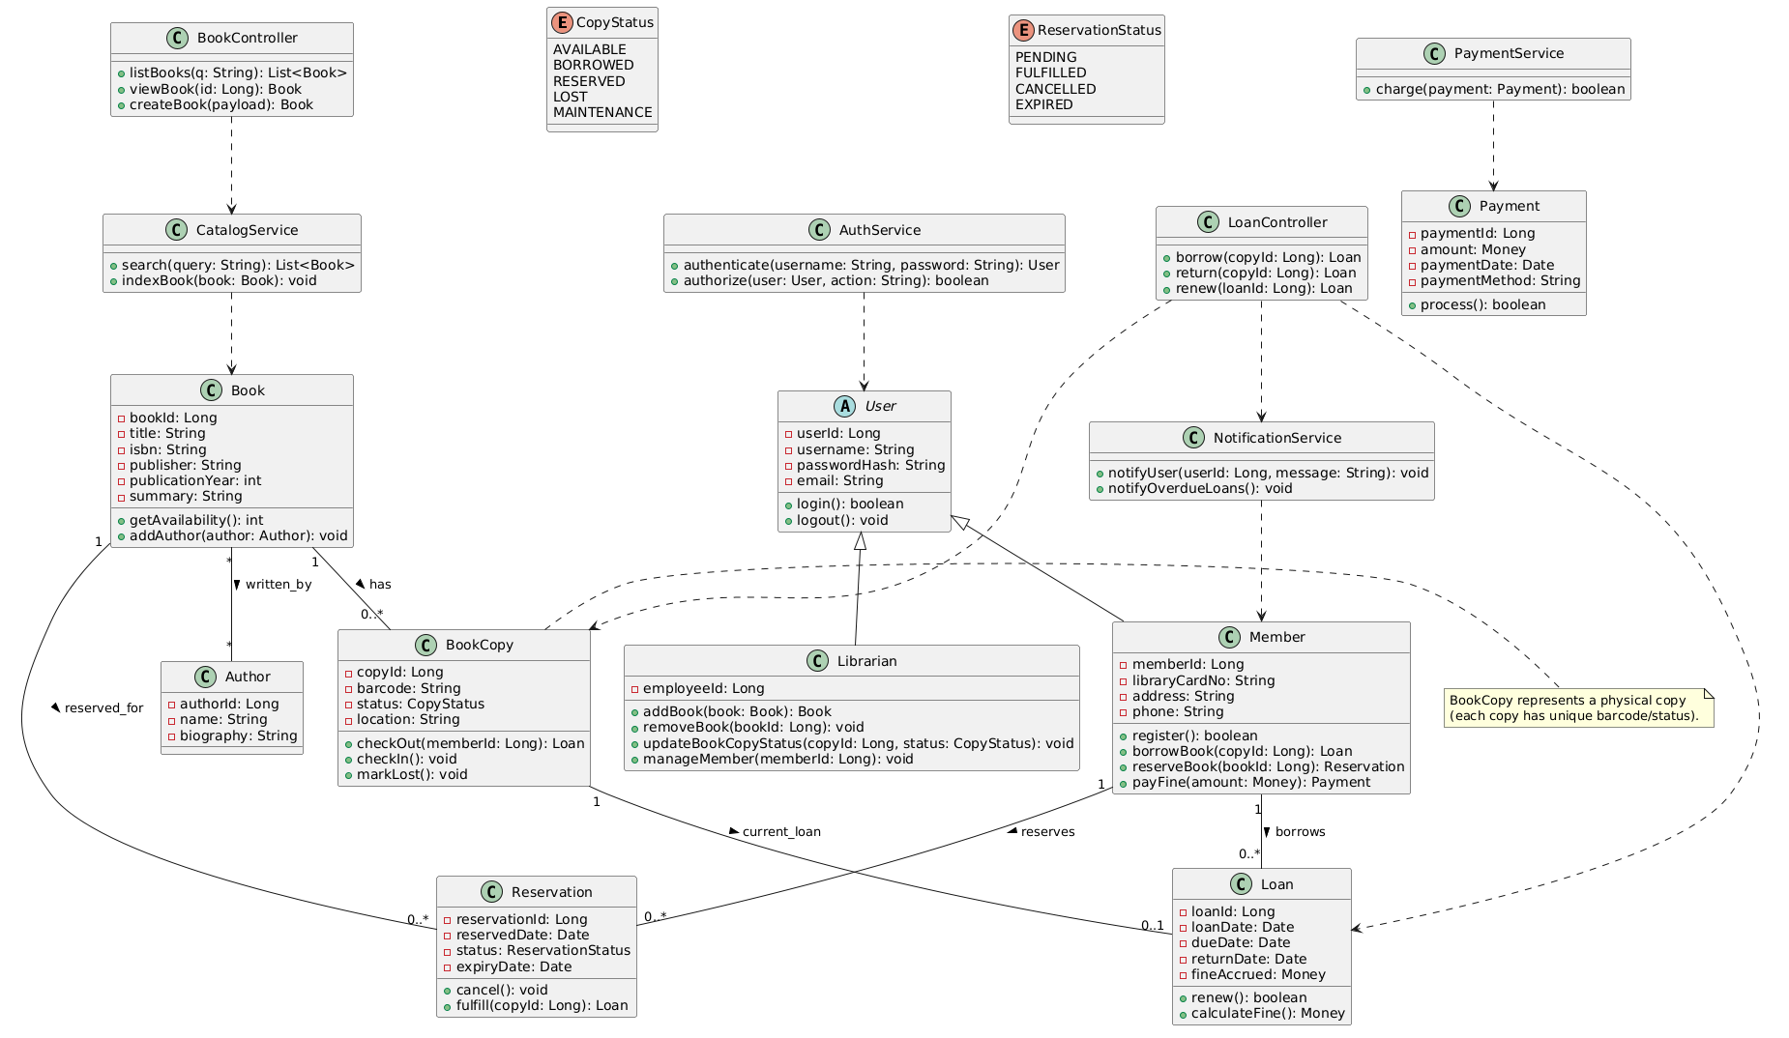
Figure 1: Class Diagram

Sequence Diagram
Sequence diagram is one of the graphical techniques used in illustrating the interactions among different parts within the system that assist in accomplishing a specified task. Sequence diagram depicts the interaction of message flow in a certain sequence.
    - Sequence Diagram for Sign Up
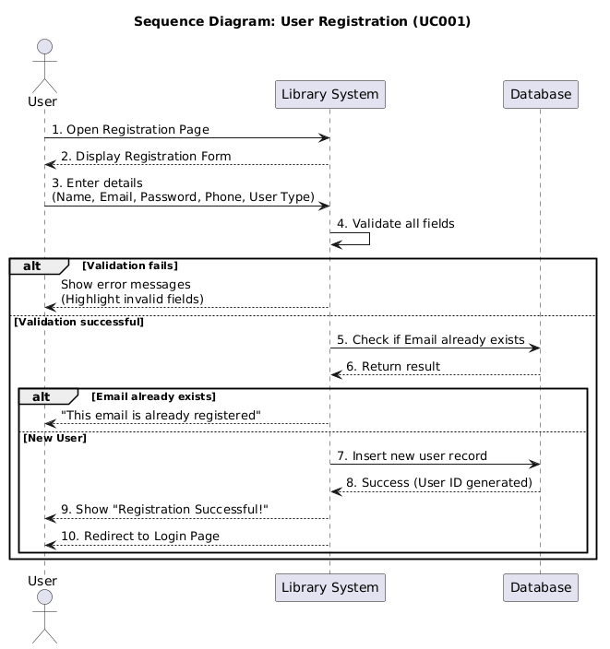
Figure 2: Sign Up Sequence Diagram

Login Sequence Diagram

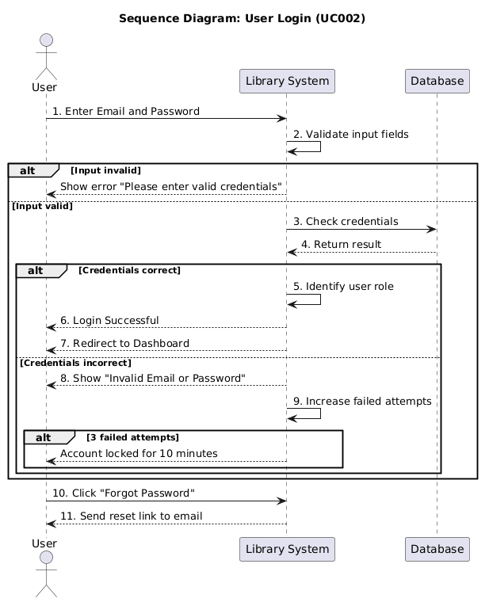
Figure 3: Login Sequence Diagram

Search Book Sequence Diagram

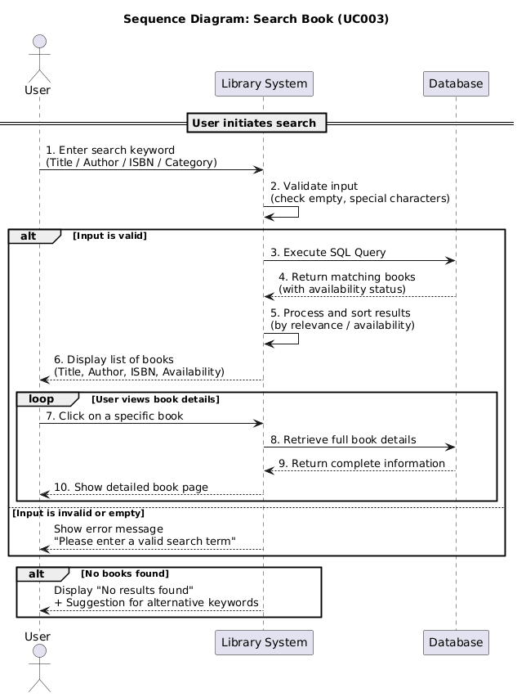
Figure 4: Issue Book Sequence Diagram

Issue Book Sequence Diagram

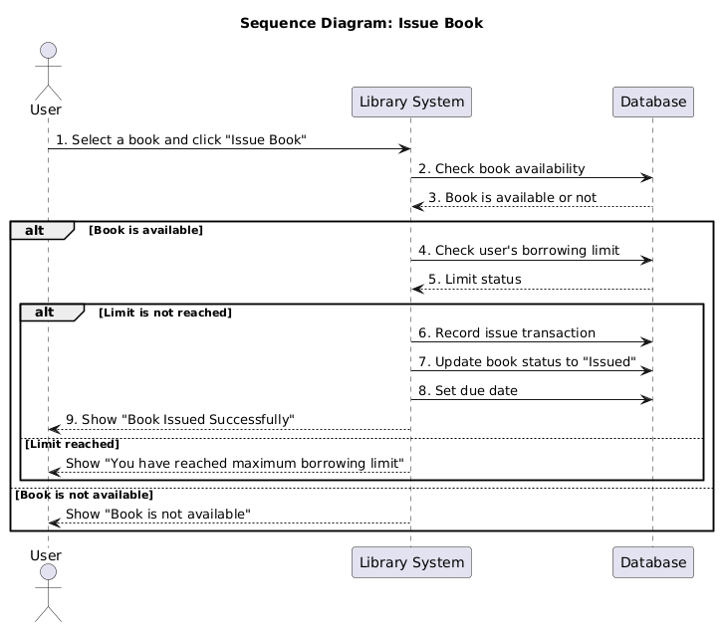
Figure 5: Issue Book Sequence Diagram

Return Book Sequence Diagram

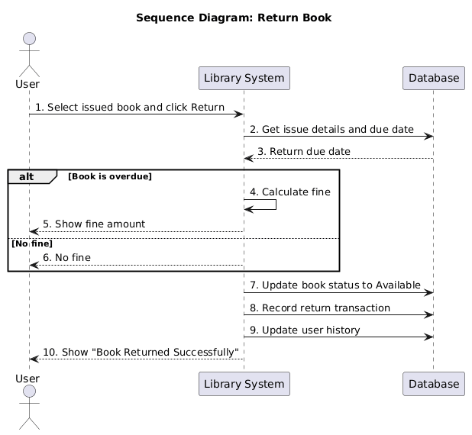
Figure 5: Return Book Sequence Diagram

Add new Book Sequence Diagram

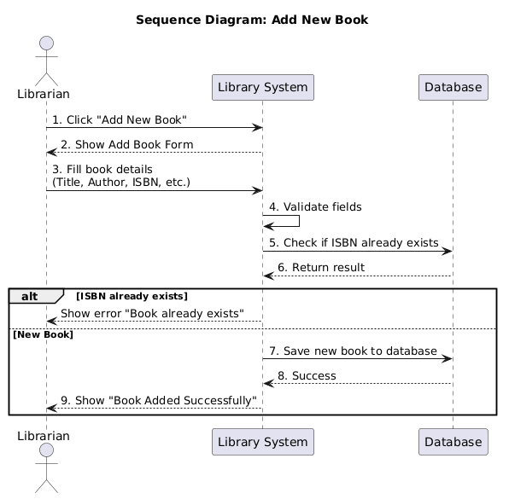
Figure 7: Add New Book Sequence Diagram

1.7 Coding Conventions
- File naming: CamelCase (e.g., UserController.php)
- Variable naming: camelCase
- Function naming: camelCase with descriptive names
- Indentation: 4 spaces
- Comments: Used for every major function and complex logic
- Database queries: Prepared statements to prevent SQL injection
- Folder structure: /controllers, /models, /views, /assets, /config

- Data Model Schema

Introduction to Database Design
The database uses MySQL and follows normalization rules up to 3NF (Third Normal Form). It consists of five main entities with well-defined relationships to support all major operations such as book issuance, return, reservation, fine calculation, and reporting.

Database Normalization
To ensure data integrity, eliminate redundancy, and avoid anomalies (insertion, update, and deletion anomalies), the database of Library Track has been designed following normalization rules up to Third Normal Form (3NF).
  - Normalization
Normalization is the process of organizing data in a database to reduce redundancy and dependency by dividing large tables into smaller ones and defining relationships between them.

First Normal Form:
A table is in 1NF if:
- All attributes have atomic (single, indivisible) values.
- Each column contains values of the same data type.
- Each record is unique (no duplicate rows).
- No repeating groups or arrays.
Example in Library Track:
- Before 1NF: A Books table might have a column author with value "Ahmed, Ali, Sara".
After 1NF: We create a separate Book_Authors table or keep only one author per row (atomic value).
Status in Our Design: All tables are in 1NF (No multi-valued attributes).

Second Normal Form:
A table is in 2NF if:
- It is in 1NF, and
- All non-key attributes are fully functionally dependent on the entire primary key (no partial dependency).
Example in Library Track:
- Suppose we had a table Issued_Books with composite key (user_id, book_id) and a column user_name.
- user_name depends only on user_id → Partial Dependency (violates 2NF).
Solution Applied: We separated Users table so that user details are not repeated in Issued_Books.
Status in Our Design: All tables are in 2NF.

Third Normal Form:
A table is in 3NF if:
- It is in 2NF, and
- There are no transitive dependencies (non-key attributes should not depend on other non-key attributes).
Example in Library Track:
- Suppose Issued_Books table had user_name and user_phone.
- These depend on user_id, not directly on issue_id → Transitive Dependency.
Solution Applied: We created a separate Users table. Only user_id (foreign key) is stored in Issued_Books.
Status in Our Design: The entire database is in 3NF.

Entities and Attributes

Entity
  - An identifiable thing (physical or conceptual) in the domain.
  - Represented as a table (relation) in a relational database or as an entity box in an ER diagram.
  - Can be an entity type (class) with many instances (rows).
  - Common kinds: strong (has its own key) and weak (depends on another entity).
Attribute
  - A named property of an entity that holds a value for each instance.
  - One or more attributes together can form a key (uniquely identify an entity instance).
  - In ER diagrams keys are typically underlined.

Users Table

Attribute | Data Type | Constraints | Description
user_id | INT | PRIMARY KEY, AUTO_INCREMENT | Unique identifier for each user
name | VARCHAR(100) | NOT NULL | Full name of student/faculty/staff
email | VARCHAR(100) | NOT NULL, UNIQUE | University email address
password | VARCHAR(255) | NOT NULL | Hashed password
phone | VARCHAR(15) | NOT NULL | Contact number
user_type | ENUM | NOT NULL | Values: 'student', 'faculty', 'librarian'
status | ENUM | DEFAULT 'active' | active / inactive / suspended
created_at | TIMESTAMP | DEFAULT CURRENT_TIMESTAMP | Account creation date
updated_at | TIMESTAMP | DEFAULT CURRENT_TIMESTAMP ON UPDATE CURRENT_TIMESTAMP | Last update

Books Table

Attribute | Data Type | Constraints | Description
book_id | INT | PRIMARY KEY, AUTO_INCREMENT | Unique book identifier
Title | VARCHAR(255) | NOT NULL | Book title
Author | VARCHAR(150) | NOT NULL | Author name
Isbn | VARCHAR(20) | UNIQUE | International Standard Book Number
publisher | VARCHAR(100) | NULL | Publisher name
Edition | VARCHAR(50) | NULL | Book edition
Category | VARCHAR(100) | NULL | Category (Computer Science, Literature, etc.)
Quantity | INT | NOT NULL, DEFAULT 1 | Total copies available
Available | INT | NOT NULL, DEFAULT 1 | Currently available copies
Price | DECIMAL(10,2) | NULL | Book price
Status | ENUM | DEFAULT 'available' | available / issued / reserved
added_at | TIMESTAMP | DEFAULT CURRENT_TIMESTAMP | Date book was added

Issued_Books Table

Attribute | Data Type | Constraints | Description
issue_id | INT | PRIMARY KEY, AUTO_INCREMENT | Unique issue transaction ID
user_id | INT | FOREIGN KEY | Reference to Users table
book_id | INT | FOREIGN KEY | Reference to Books table
issue_date | DATE | NOT NULL | Date when book was issued
due_date | DATE | NOT NULL | Expected return date
return_date | DATE | NULL | Actual return date
fine_amount | DECIMAL(10,2) | DEFAULT 0.00 | Fine if returned late
Status | ENUM | DEFAULT 'issued' | issued / returned / overdue

Reservations Table

Attribute | Data Type | Constraints | Description
reservation_id | INT | PRIMARY KEY, AUTO_INCREMENT | Unique reservation ID
user_id | INT | FOREIGN KEY | User who reserved the book
book_id | INT | FOREIGN KEY | Reserved book
reservation_date | DATE | NOT NULL | Date of reservation
status | ENUM | DEFAULT 'pending' | pending / fulfilled / cancelled

Fines Table

Attribute | Data Type | Constraints | Description
fine_id | INT | PRIMARY KEY, AUTO_INCREMENT | Unique fine record ID
issue_id | INT | FOREIGN KEY | Reference to Issued_Books
user_id | INT | FOREIGN KEY | User who owes the fine
amount | DECIMAL(10,2) | NOT NULL | Fine amount
status | ENUM | DEFAULT 'unpaid' | unpaid / paid
paid_date | DATE | NULL | Date fine was paid

Entity Relationships
- Users to Issued_Books: One-to-Many (One user can borrow multiple books)
- Books to Issued_Books: One-to-Many (One book can be issued multiple times over time)
- Users to Reservations: One-to-Many (One user can reserve multiple books)
- Books to Reservations: One-to-Many (One book can have multiple reservations)
- Issued_Books to Fines: One-to-One (Each issued book may have one fine record)

ER Diagram

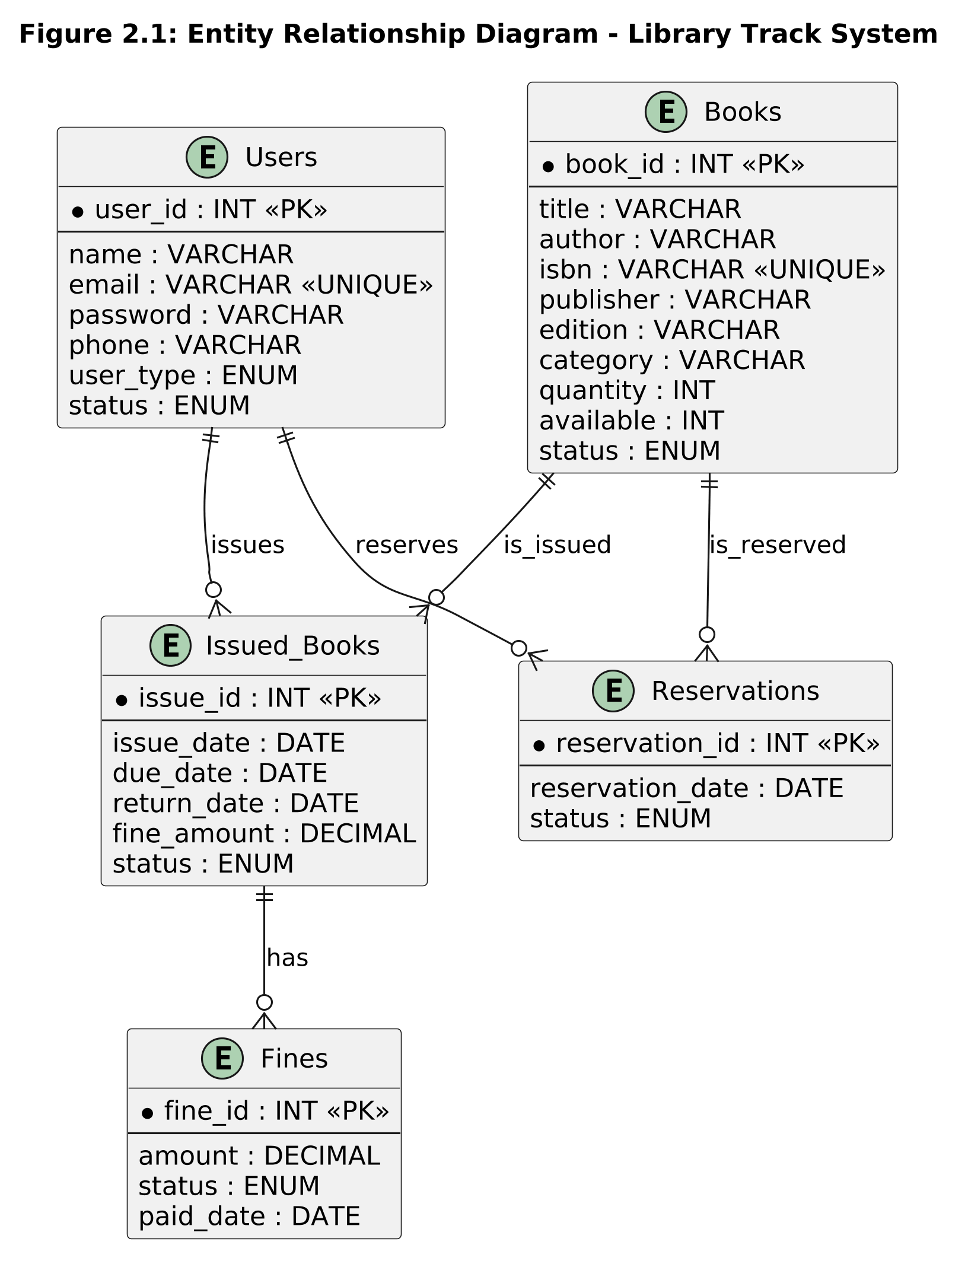
Figure 2.1: Entity Relationship Diagram of Library Management System

User Interface

Design Philosophy
Color Scheme:
Primary color #007BFF (Blue)
Accent #28A745 (Green)
Neutral #F8F9FA (Light Gray) and #343A40 (Dark Gray).
Font:
Poppins (Google Font) – Modern, clean, and highly readable.
Design Niche:
Minimal, Card-based, Flat design with subtle shadows and hover effects.
Responsiveness:
Fully responsive design using Bootstrap 5. Optimized for Desktop, Tablet, and Mobile screens (minimum 320px width).
Design Goal:
Professional, intuitive, and accessible for students, faculty, and library staff.

List of Screens/Pages
- Login Page
- Registration Page
- User Dashboard
- Book Search & Browse
- Book Details Page
- Issue Book Page
- Return Book Page
- My Borrowed Books
- Admin Dashboard
- Manage Books (Add/Update/Delete)
- Defaulter List & Reports

Screen-wise Design Details

Login Page
Purpose:
This page allows already registered users (students and faculty members) to “Sign In” in the Smart Library Management system.

Figure 3.1: Login Page
- Controls: Email Input, Password Input, Login Button, Forgot Password Link, Register Link
- Input Constraints: Email must be valid, Password minimum 8 characters
- Data: University email only.

Login.php
<?php
session_start();
// Check if user is already logged in
if (isset($_SESSION['user_id'])) {
header("Location: dashboard.php");
exit();
}
$error_message = '';
// Handle login form submission
if ($_SERVER['REQUEST_METHOD'] === 'POST') {
$user_id = isset($_POST['user_id']) ? trim($_POST['user_id']) : '';
$password = isset($_POST['password']) ? $_POST['password'] : '';
// Validate inputs
if (empty($user_id) || empty($password)) {
$error_message = 'Please enter both User ID/Email and Password';
} else {
// TODO: Implement database authentication
// This is a placeholder - replace with actual database verification
// Example: $user = authenticateUser($user_id, $password);
// Temporary validation for testing
if ($user_id === 'admin' && $password === 'password123') {
$_SESSION['user_id'] = $user_id;
$_SESSION['user_name'] = 'Admin User';
header("Location: dashboard.php");
exit();
} else {
$error_message = 'Invalid User ID/Email or Password';
}
}
}
?>

<!DOCTYPE html>
<html lang="en">
<head>
<meta charset="UTF-8">
<meta name="viewport" content="width=device-width, initial-scale=1.0">
<title>Sign In - Smart Library Management System</title>
<!-- Bootstrap CSS -->
<link href="https://cdn.jsdelivr.net/npm/bootstrap@5.3.0/dist/css/bootstrap.min.css" rel="stylesheet">
<!-- Font Awesome for icons -->
<link rel="stylesheet" href="https://cdnjs.cloudflare.com/ajax/libs/font-awesome/6.4.0/css/all.min.css">
<!-- Error Message -->
<?php if (!empty($error_message)): ?>
<div class="alert alert-danger alert-dismissible fade show" role="alert">
<i class="fas fa-exclamation-circle me-2"></i>
<?php echo htmlspecialchars($error_message); ?>
<button type="button" class="btn-close" data-bs-dismiss="alert"></button>
</div>
<?php endif; ?>
<!-- Login Form -->
<form method="POST" action="<?php echo $_SERVER['PHP_SELF']; ?>" novalidate>
<!-- User ID/Email Field -->
<div class="mb-3">
<label for="user_id" class="form-label visually-hidden">User ID or Email</label>
<div class="input-group input-group-lg">
<span class="input-group-text bg-white border-end-0">
<i class="fas fa-user text-secondary"></i>
</span>
<input
type="text"
class="form-control border-start-0"
id="user_id"
name="user_id"
placeholder="User ID or Email"
required
autocomplete="username"
>
</div>
</div>
<!-- Password Field -->
<div class="mb-3">
<label for="password" class="form-label visually-hidden">Password</label>
<div class="input-group input-group-lg">
<span class="input-group-text bg-white border-end-0">
<i class="fas fa-lock text-secondary"></i>
</span>
<input
type="password"
class="form-control border-start-0"
id="password"
name="password"
placeholder="Password"
required
autocomplete="current-password"
>
</div>
</div>
<!-- Forgot Password Link -->
<div class="text-end mb-4">
<a href="forgot-password.php" class="text-decoration-none forgot-password-link">
Forgot password?
</a>
</div>
<!-- Sign In Button -->
<button type="submit" class="btn btn-login btn-lg w-100 fw-bold mb-3">
Sign In
</button>
</form>
<!-- Sign Up Link -->
<div class="text-center">
<p class="text-muted">Don't have an account?
<a href="signup.php" class="text-decoration-none signup-link fw-semibold">
Sign up
</a>
</p>
</div>
<!-- Footer -->
<hr class="my-4">
<p class="text-center text-muted small">
<i class="fas fa-shield-alt me-1"></i>
Your login credentials are secure and encrypted
</p> </div> </div> </div> </div>

User Registration
Purpose:
This page allows new users (Admin, students and faculty members) to create an account in the Smart Library Management system.

Figure 3.2: Sign Up Page
- Controls: First Name Input, Last Name Input, Library Card Input, Email Input, Password Input, Confirm Password Input, Sign Up Button, Sign in Link
- Input Constraints: All Information’s Must be entered in following Fields (First Name Input, Last Name Input, Library Card Input, Email Input, Password Input, Confirm Password Input) Email must be valid, Password minimum 8 characters used.
- Data: University email and Library Card ID only used.

signup.php

<?php
session_start();
// Check if user is already logged in
if (isset($_SESSION['user_id'])) {
header("Location: dashboard.php");
exit();
}
$errors = [];
$success_message = '';
$form_data = [];
// Handle signup form submission
if ($_SERVER['REQUEST_METHOD'] === 'POST') {
$form_data = [
'first_name' => isset($_POST['first_name']) ? trim($_POST['first_name']) : '',
'last_name' => isset($_POST['last_name']) ? trim($_POST['last_name']) : '',
'library_card' => isset($_POST['library_card']) ? trim($_POST['library_card']) : '',
'email' => isset($_POST['email']) ? trim($_POST['email']) : '',
'password' => isset($_POST['password']) ? $_POST['password'] : '',
'confirm_password' => isset($_POST['confirm_password']) ? $_POST['confirm_password'] : ''
];
// Validation
if (empty($form_data['first_name'])) {
$errors[] = 'First name is required';
} elseif (strlen($form_data['first_name']) < 2) {
$errors[] = 'First name must be at least 2 characters';
}
if (empty($form_data['last_name'])) {
$errors[] = 'Last name is required';
} elseif (strlen($form_data['last_name']) < 2) {
$errors[] = 'Last name must be at least 2 characters';
}
if (empty($form_data['library_card'])) {
$errors[] = 'Library Card or User ID is required';
} elseif (strlen($form_data['library_card']) < 3) {
$errors[] = 'Library Card must be at least 3 characters';
}
if (empty($form_data['email'])) {
$errors[] = 'Email address is required';
} elseif (!filter_var($form_data['email'], FILTER_VALIDATE_EMAIL)) {
$errors[] = 'Please enter a valid email address';
}
if (empty($form_data['password'])) {
$errors[] = 'Password is required';
} elseif (strlen($form_data['password']) < 8) {
$errors[] = 'Password must be at least 8 characters';
} elseif (!preg_match('/[A-Z]/', $form_data['password'])) {
$errors[] = 'Password must contain at least one uppercase letter';
} elseif (!preg_match('/[0-9]/', $form_data['password'])) {
$errors[] = 'Password must contain at least one number';
} elseif (!preg_match('/[!@#$%^&*]/', $form_data['password'])) {
$errors[] = 'Password must contain at least one special character (!@#$%^&*)';
}
if (empty($form_data['confirm_password'])) {
$errors[] = 'Please confirm your password';
} elseif ($form_data['password'] !== $form_data['confirm_password']) {
$errors[] = 'Passwords do not match';
}
// If no errors, process registration
if (empty($errors)) {
// TODO: Implement database registration
// Example: $result = registerUser($form_data);
// For now, show success message
$success_message = 'Account created successfully! Please log in.';
$form_data = []; // Clear form
}
}
?>

<!DOCTYPE html>
<html lang="en">
<head>
<meta charset="UTF-8">
<meta name="viewport" content="width=device-width, initial-scale=1.0">
<title>Sign Up - Smart Library Management System</title>
<!-- Bootstrap CSS -->
<link href="https://cdn.jsdelivr.net/npm/bootstrap@5.3.0/dist/css/bootstrap.min.css" rel="stylesheet">
<!-- Font Awesome for icons -->
<link rel="stylesheet" href="https://cdnjs.cloudflare.com/ajax/libs/font-awesome/6.4.0/css/all.min.css">
<!-- Right Section - Signup Form -->
<div class="col-lg-6 col-md-10 col-12 mx-auto">
<div class="signup-card">
<!-- Success Message -->
<?php if (!empty($success_message)): ?>
<div class="alert alert-success alert-dismissible fade show" role="alert">
<i class="fas fa-check-circle me-2"></i>
<?php echo htmlspecialchars($success_message); ?>
<br>
<small><a href="login.php" class="alert-link">Click here to sign in</a></small>
<button type="button" class="btn-close" data-bs-dismiss="alert"></button>
</div>
<?php endif; ?>
<!-- Error Messages -->
<?php if (!empty($errors)): ?>
<div class="alert alert-danger alert-dismissible fade show" role="alert">
<i class="fas fa-exclamation-circle me-2"></i>
<strong>Please fix the following errors:</strong>
<ul class="mb-0 mt-2">
<?php foreach ($errors as $error): ?>
<li><?php echo htmlspecialchars($error); ?></li>
<?php endforeach; ?>
</ul>
<button type="button" class="btn-close" data-bs-dismiss="alert"></button>
</div>
<?php endif; ?>
<!-- Signup Form -->
<form method="POST" action="<?php echo $_SERVER['PHP_SELF']; ?>" novalidate id="signupForm">
<!-- First Name Field -->
<div class="mb-3">
<label for="first_name" class="form-label visually-hidden">First Name</label>
<div class="input-group input-group-lg">
<span class="input-group-text bg-white border-end-0">
<i class="fas fa-user text-secondary"></i>
</span>
<input
type="text"
class="form-control border-start-0"
id="first_name"
name="first_name"
placeholder="First Name"
value="<?php echo htmlspecialchars($form_data['first_name'] ?? ''); ?>"
required
>
</div>
</div>
<!-- Last Name Field -->
<div class="mb-3">
<label for="last_name" class="form-label visually-hidden">Last Name</label>
<div class="input-group input-group-lg">
<span class="input-group-text bg-white border-end-0">
<i class="fas fa-user text-secondary"></i>
</span>
<input
type="text"
class="form-control border-start-0"
id="last_name"
name="last_name"
placeholder="Last Name"
value="<?php echo htmlspecialchars($form_data['last_name'] ?? ''); ?>"
required
>
</div>
</div>
<!-- Library Card Field -->
<div class="mb-3">
<label for="library_card" class="form-label visually-hidden">Library Card or User ID</label>
<div class="input-group input-group-lg">
<span class="input-group-text bg-white border-end-0">
<i class="fas fa-id-card text-secondary"></i>
</span>
<input
type="text"
class="form-control border-start-0"
id="library_card"
name="library_card"
placeholder="Library Card or User ID"
value="<?php echo htmlspecialchars($form_data['library_card'] ?? ''); ?>"
required
>
</div> </div>
<!-- Email Field -->
<div class="mb-3">
<label for="email" class="form-label visually-hidden">Email Address</label>
<div class="input-group input-group-lg">
<span class="input-group-text bg-white border-end-0">
<i class="fas fa-envelope text-secondary"></i>
</span>
<input
type="email"
class="form-control border-start-0"
id="email"
name="email"
placeholder="Email Address"
value="<?php echo htmlspecialchars($form_data['email'] ?? ''); ?>"
required
>
</div> </div>
<!-- Password Field -->
<div class="mb-3">
<label for="password" class="form-label visually-hidden">Password</label>
<div class="input-group input-group-lg">
<span class="input-group-text bg-white border-end-0">
<i class="fas fa-lock text-secondary"></i>
</span>
<input
type="password"
class="form-control border-start-0"
id="password"
name="password"
placeholder="Password"
required
>
</div>
<small class="form-text text-muted d-block mt-2">
<i class="fas fa-info-circle me-1"></i>
At least 8 characters with 1 uppercase, 1 number, and 1 special character (!@#$%^&*)
</small>
</div>
<!-- Confirm Password Field -->
<div class="mb-3">
<label for="confirm_password" class="form-label visually-hidden">Confirm Password</label>
<div class="input-group input-group-lg">
<span class="input-group-text bg-white border-end-0">
<i class="fas fa-lock text-secondary"></i>
</span>
<input
type="password"
class="form-control border-start-0"
id="confirm_password"
name="confirm_password"
placeholder="Confirm Password"
required
>
</div> </div>
<!-- Sign Up Button -->
<button type="submit" class="btn btn-signup btn-lg w-100 fw-bold mb-3">
Sign Up
</button>
</form>
<!-- Sign In Link -->
<div class="text-center">
<p class="text-muted">Already have an account?
<a href="login.php" class="text-decoration-none signin-link fw-semibold">
Sign in
</a>
</p> </div>

User Dashboard
Purpose:
This page shows different statics about borrowed books also show recommendations in the Smart Library Management system.
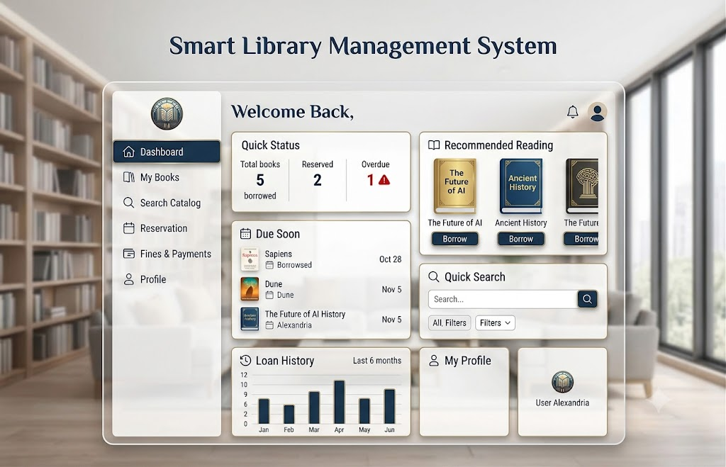
Figure 3.3: User Dashboard Page

- Controls: Welcome Card, Quick Stats (Books Borrowed, Due Soon), Search Bar, Navigation Sidebar
- Data Displayed: Borrowed books list, Due dates, Notifications

3.3.4.1 User Dashboard.php
<?php
session_start();
// Check if user is logged in
if (!isset($_SESSION['user_id'])) {
header("Location: login.php");
exit();
}
// TODO: Fetch user data from database
$user = [
'id' => $_SESSION['user_id'],
'name' => $_SESSION['user_name'] ?? 'User Alexandria',
'email' => 'user@library.com',
'member_since' => '2023-01-15',
'profile_pic' => 'https://via.placeholder.com/100'
];
// Quick Status Data
$quickStatus = [
'total_books' => 5,
'reserved' => 2,
'overdue' => 1
];
// Due Soon Books
$dueSoonBooks = [
[
'title' => 'Sapiens',
'author' => 'Yuval Noah Harari',
'due_date' => '2024-10-28',
'status' => 'Borrowed',
'cover' => 'https://via.placeholder.com/60x90?text=Sapiens'
],
[
'title' => 'Dune',
'author' => 'Frank Herbert',
'due_date' => '2024-11-05',
'status' => 'Dune',
'cover' => 'https://via.placeholder.com/60x90?text=Dune'
],
[
'title' => 'The Future of AI History',
'author' => 'Alexandria',
'due_date' => '2024-11-05',
'status' => 'Status',
'cover' => 'https://via.placeholder.com/60x90?text=FutureAI'
]
];
// Recommended Reading
$recommendedBooks = [
[
'title' => 'The Future of AI',
'author' => 'Tech Author',
'cover' => 'https://via.placeholder.com/120x160?text=FutureAI',
'available' => true
],
[
'title' => 'Ancient History',
'author' => 'History Expert',
'cover' => 'https://via.placeholder.com/120x160?text=AncientHist',
'available' => true
],
[
'title' => 'The Future',
'author' => 'Future Author',
'cover' => 'https://via.placeholder.com/120x160?text=TheFuture',
'available' => false
]
];
// Loan History Data (for chart)
$loanHistory = [
['month' => 'Jan', 'count' => 5],
['month' => 'Feb', 'count' => 3],
['month' => 'Mar', 'count' => 7],
['month' => 'Apr', 'count' => 8],
['month' => 'May', 'count' => 4],
['month' => 'Jun', 'count' => 6]
];
// Handle logout
if (isset($_GET['action']) && $_GET['action'] === 'logout') {
session_destroy();
header("Location: login.php");
exit();
}
?>

<!DOCTYPE html>
<html lang="en">
<head>
<meta charset="UTF-8">
<meta name="viewport" content="width=device-width, initial-scale=1.0">
<title>Dashboard - Smart Library Management System</title>
<!-- Bootstrap CSS -->
<link href="https://cdn.jsdelivr.net/npm/bootstrap@5.3.0/dist/css/bootstrap.min.css" rel="stylesheet
<!-- Font Awesome for icons -->
<link rel="stylesheet" href="https://cdnjs.cloudflare.com/ajax/libs/font-awesome/6.4.0/css/all.min.css">
<!-- Logout Button -->
<div class="sidebar-footer">
<a href="dashboard.php?action=logout" class="btn btn-logout w-100">
<i class="fas fa-sign-out-alt me-2"></i>
Logout
</a>
</div>
</nav>
<!-- Main Content -->
<main class="col-lg-9 col-xl-10 content-area">
<!-- Header -->
<header class="dashboard-header">
<div class="header-content">
<h1 class="mb-0">Welcome Back, <?php echo htmlspecialchars($user['name']); ?></h1>
</div>
<div class="header-actions">
<button class="btn btn-icon notification-btn" title="Notifications">
<i class="fas fa-bell"></i>
<span class="badge">3</span>
</button>
<button class="btn btn-icon profile-btn" title="Profile">
<i class="fas fa-user-circle"></i>
</button>
</div>
</header>
<!-- Dashboard Content -->
<div class="dashboard-content">
<div class="row g-4">
<!-- Quick Status -->
<div class="col-lg-6">
<div class="card dashboard-card">
<div class="card-body">
<h5 class="card-title mb-4">
<i class="fas fa-tachometer-alt me-2"></i>
Quick Status
</h5>
<div class="row text-center">
<div class="col-4">
<div class="status-item">
<div class="status-number"><?php echo $quickStatus['total_books']; ?></div>
<div class="status-label">Total books borrowed</div>
</div>
</div>
<div class="col-4">
<div class="status-item">
<div class="status-number"><?php echo $quickStatus['reserved']; ?></div>
<div class="status-label">Reserved</div>
</div>
</div>
<div class="col-4">
<div class="status-item">
<div class="status-number overdue"><?php echo $quickStatus['overdue']; ?><i class="fas fa-triangle-exclamation"></i></div>
<div class="status-label">Overdue</div>
</div>
</div>
</div>
</div>
</div>
</div>
<!-- Due Soon -->
<div class="col-lg-6">
<div class="card dashboard-card">
<div class="card-body">
<h5 class="card-title mb-4">
<i class="fas fa-calendar-alt me-2"></i>
Due Soon
</h5>
<div class="due-soon-list">
<?php foreach ($dueSoonBooks as $book): ?>
<div class="due-item">
<div class="due-book-info">
<div class="due-title"><?php echo htmlspecialchars($book['title']); ?></div>
<div class="due-meta">
<span class="badge bg-primary"><?php echo htmlspecialchars($book['status']); ?></span>
<span class="due-date">
<i class="fas fa-calendar me-1"></i>
<?php echo date('M d', strtotime($book['due_date'])); ?>
</span>
</div>
</div>
</div>
<?php endforeach; ?>
</div>
</div>
</div>
</div>
<!-- Recommended Reading -->
<div class="col-lg-6">
<div class="card dashboard-card">
<div class="card-body">
<h5 class="card-title mb-4">
<i class="fas fa-star me-2"></i>
Recommended Reading
</h5>
<div class="recommended-books">
<?php foreach ($recommendedBooks as $book): ?>
<div class="book-item">
<div class="book-cover">
<img src="<?php echo htmlspecialchars($book['cover']); ?>" alt="<?php echo htmlspecialchars($book['title']); ?>">
</div>
<div class="book-info">
<h6><?php echo htmlspecialchars($book['title']); ?></h6>
<small><?php echo htmlspecialchars($book['author']); ?></small>
</div>
<button class="btn btn-sm <?php echo $book['available'] ? 'btn-primary' : 'btn-secondary'; ?>"
<?php echo !$book['available'] ? 'disabled' : ''; ?>>
<?php echo $book['available'] ? 'Borrow' : 'Reserved'; ?>
</button>
</div>
<?php endforeach; ?>
</div>
</div>
</div>
</div>
<!-- Quick Search -->
<div class="col-lg-6">
<div class="card dashboard-card">
<div class="card-body">
<h5 class="card-title mb-4">
<i class="fas fa-search me-2"></i>
Quick Search
</h5>
<div class="search-box">
<form class="d-flex gap-2" onsubmit="handleSearch(event)">
<input type="text" class="form-control" placeholder="Search for books...">
<button type="submit" class="btn btn-search">
<i class="fas fa-search"></i>
</button>
</form>
</div>
<div class="search-filters mt-3">
<button class="filter-btn active">All</button>
<button class="filter-btn">Filters <i class="fas fa-chevron-down ms-1"></i></button>
</div>
</div>
</div>
</div>
<!-- Loan History Chart -->
<div class="col-lg-6">
<div class="card dashboard-card">
<div class="card-body">
<h5 class="card-title mb-4">
<i class="fas fa-history me-2"></i>
Loan History <small class="text-muted">Last 6 months</small>
</h5>
<canvas id="loanHistoryChart"></canvas>
</div>
</div>
</div>

Book Search & Browse
Purpose:
This page allows users to search and borrow book by using this page in the Smart Library Management system.
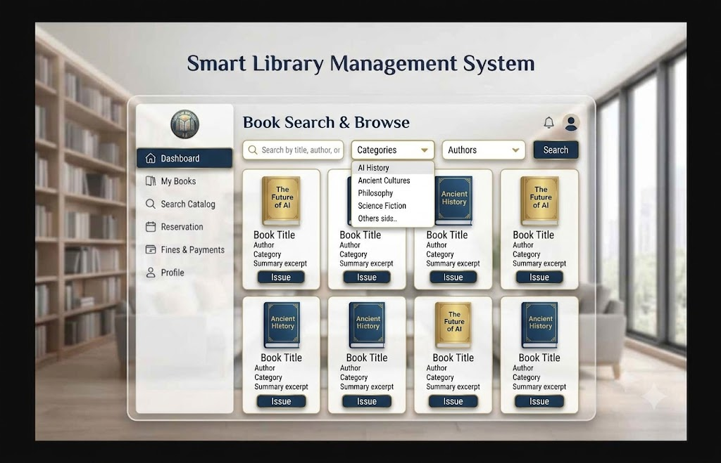
Figure 3.4: Book Search & Browse Page
- Controls: Search Textbox, Category Dropdown, Author Filter, Search Button, Book Cards (with Issue Button)
- Input Constraints: Search term minimum 2 characters

Book Details Page
Purpose:
This page shows the detail about specific book that is available on this Smart Library Management system.
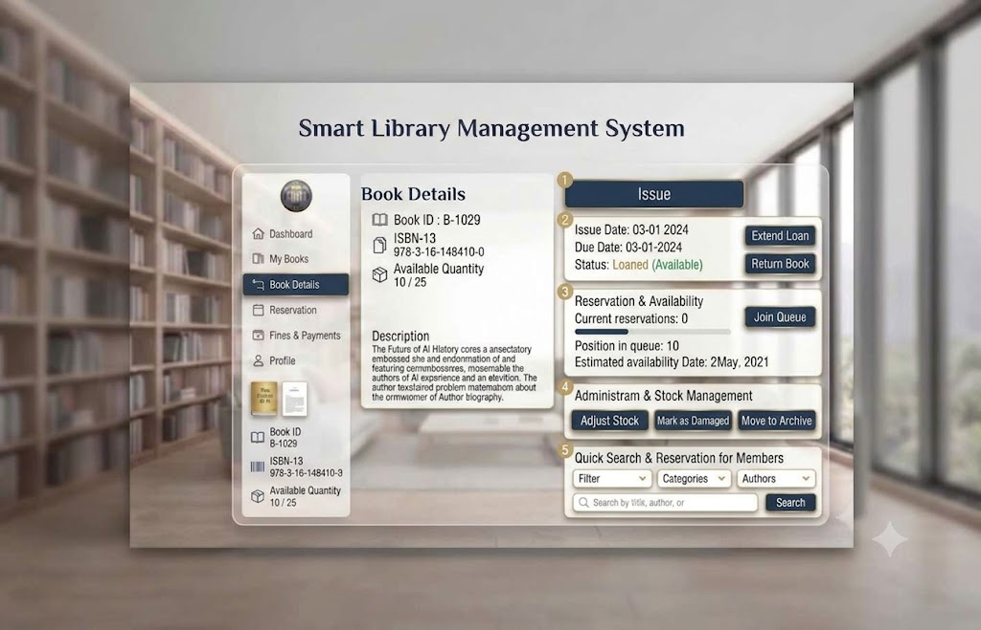
Figure 3.5: Book Detail Page
- Controls: Book Details Card, Quick Search and Reservation Bar, Search Bar, Navigation Sidebar
- Data Displayed: Books Description, Issue dates, Notifications

Issue Book Page
Purpose:
This page allows to issue books also sow fine card and due date calculation.
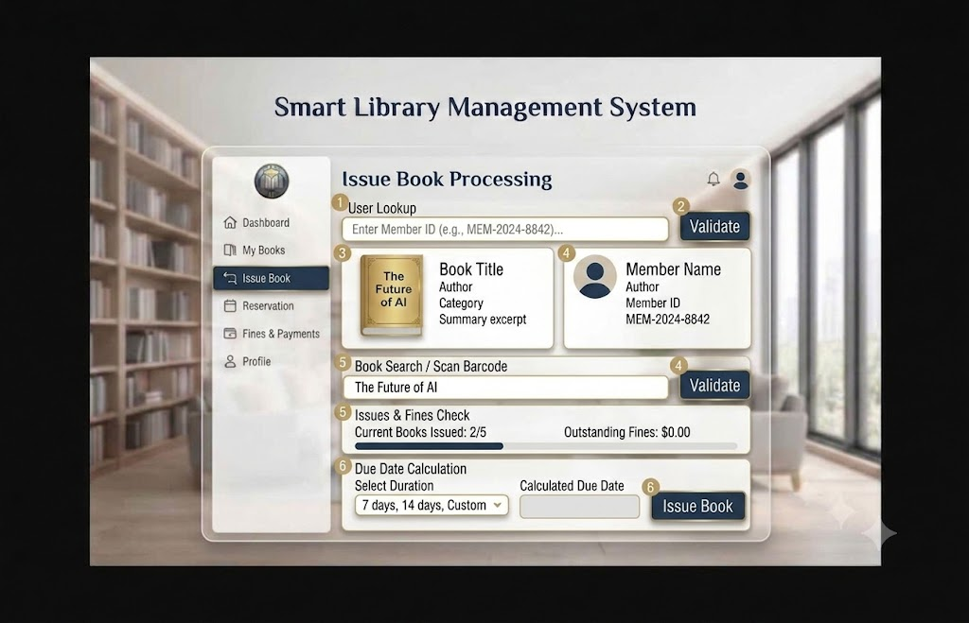
Figure 3.6: Book Issue Page
- Controls: Book ID / Search, User ID (Auto-filled), Issue Button, Due Date Display
- Input Constraints: Book must be available, User must not exceed borrowing limit

issue-book.php
<?php
session_start();

// Check if user is logged in
if (!isset($_SESSION['user_id'])) {
header("Location: login.php");
exit();
}

$errors = [];
$success_message = '';
$user_data = null;
$book_data = null;
$issue_summary = null;

// Handle form submission
if ($_SERVER['REQUEST_METHOD'] === 'POST') {
$action = isset($_POST['action']) ? $_POST['action'] : '';

if ($action === 'validate_member') {
$member_id = isset($_POST['member_id']) ? trim($_POST['member_id']) : '';

if (empty($member_id)) {
$errors[] = 'Please enter a Member ID';
} else {
// TODO: Fetch member data from database
// For now, simulate with sample data
$user_data = [
'member_id' => $member_id,
'name' => 'John Alexandria',
'email' => 'john@library.com',
'phone' => '+1-555-0123',
'membership_status' => 'Active',
'profile_pic' => 'https://via.placeholder.com/100'
];
}
}

elseif ($action === 'validate_book') {
$book_search = isset($_POST['book_search']) ? trim($_POST['book_search']) : '';
$member_id = isset($_POST['member_id_hidden']) ? trim($_POST['member_id_hidden']) : '';

if (empty($book_search)) {
$errors[] = 'Please enter a book title or ISBN';
} elseif (empty($member_id)) {
$errors[] = 'Please validate member first';
} else {
// TODO: Fetch book data from database
// For now, simulate with sample data
$book_data = [
'isbn' => '978-0-375-50120-0',
'title' => 'The Future of AI',
'author' => 'Tech Author',
'category' => 'Technology',
'summary' => 'An insightful exploration into artificial intelligence and its impact on society.',
'available_copies' => 3,
'cover' => 'https://via.placeholder.com/120x160?text=FutureAI'
];

// Check issues and fines
$issue_summary = [
'current_books' => 2,
'max_books' => 5,
'outstanding_fines' => 0.00,
'can_issue' => true
];
}
}

elseif ($action === 'issue_book') {
$member_id = isset($_POST['member_id_hidden']) ? trim($_POST['member_id_hidden']) : '';
$book_isbn = isset($_POST['book_isbn_hidden']) ? trim($_POST['book_isbn_hidden']) : '';
$duration = isset($_POST['duration']) ? $_POST['duration'] : '7';
$custom_days = isset($_POST['custom_days']) ? (int)$_POST['custom_days'] : 0;

if (empty($member_id) || empty($book_isbn)) {
$errors[] = 'Invalid request. Please start over.';
} else {
// Validate duration
if ($duration === 'custom' && ($custom_days <= 0 || $custom_days > 60)) {
$errors[] = 'Custom duration must be between 1 and 60 days';
} else {
// TODO: Process book issuance in database
// Calculate due date
$issue_date = date('Y-m-d');
$days = ($duration === 'custom') ? $custom_days : (int)$duration;
$due_date = date('Y-m-d', strtotime("+$days days"));

// Simulate success
$success_message = "Book '{$book_data['title']}' successfully issued to {$user_data['name']}. Due date: $due_date";

// Reset form
$user_data = null;
$book_data = null;
$issue_summary = null;
}
}
}
}

// Get current issued books count (for demonstration)
$current_issues = 2;
$max_issues = 5;
$outstanding_fines = 0.00;
?>

<!DOCTYPE html>
<html lang="en">
<head>
<meta charset="UTF-8">
<meta name="viewport" content="width=device-width, initial-scale=1.0">
<title>Issue Book - Smart Library Management System</title>

<!-- Bootstrap CSS -->
<link href="https://cdn.jsdelivr.net/npm/bootstrap@5.3.0/dist/css/bootstrap.min.css" rel="stylesheet">

<!-- Font Awesome for icons -->
<link rel="stylesheet" href="https://cdnjs.cloudflare.com/ajax/libs/font-awesome/6.4.0/css/all.min.css">

<!-- Custom CSS -->
<link rel="stylesheet" href="css/issue-book-style.css">
</head>
<body class="issue-book-page">
<div class="container-fluid">
<div class="row min-vh-100">
<!-- Sidebar Navigation -->
<nav class="col-lg-3 col-xl-2 sidebar">
<div class="sidebar-header">
<div class="logo-circle mb-3">
<i class="fas fa-book"></i>
</div>
<h5 class="text-center fw-bold">Smart Library</h5>
</div>

<ul class="nav flex-column nav-menu">
<li class="nav-item">
<a class="nav-link" href="dashboard.php">
<i class="fas fa-home me-2"></i>
<span>Dashboard</span>
</a>
</li>
<li class="nav-item">
<a class="nav-link" href="my-books.php">
<i class="fas fa-book me-2"></i>
<span>My Books</span>
</a>
</li>
<li class="nav-item">
<a class="nav-link" href="search-catalog.php">
<i class="fas fa-search me-2"></i>
<span>Search Catalog</span>
</a>
</li>
<li class="nav-item">
<a class="nav-link" href="reservations.php">
<i class="fas fa-calendar me-2"></i>
<span>Reservation</span>
</a>
</li>
<li class="nav-item">
<a class="nav-link active" href="issue-book.php">
<i class="fas fa-receipt me-2"></i>
<span>Issue Book</span>
</a>
</li>
<li class="nav-item">
<a class="nav-link" href="fines-payments.php">
<i class="fas fa-receipt me-2"></i>
<span>Fines & Payments</span>
</a>
</li>
<li class="nav-item">
<a class="nav-link" href="profile.php">
<i class="fas fa-user me-2"></i>
<span>Profile</span>
</a>
</li>
</ul>

<!-- Logout Button -->
<div class="sidebar-footer">
<a href="dashboard.php?action=logout" class="btn btn-logout w-100">
<i class="fas fa-sign-out-alt me-2"></i>
Logout
</a>
</div>
</nav>

<!-- Main Content -->
<main class="col-lg-9 col-xl-10 content-area">
<!-- Header -->
<header class="page-header">
<div class="header-content">
<h1 class="mb-0">Issue Book Processing</h1>
</div>
<div class="header-actions">
<button class="btn btn-icon notification-btn" title="Notifications">
<i class="fas fa-bell"></i>
<span class="badge">3</span>
</button>
<button class="btn btn-icon profile-btn" title="Profile">
<i class="fas fa-user-circle"></i>
</button>
</div>
</header>

<!-- Content -->
<div class="issue-content">
<!-- Error Messages -->
<?php if (!empty($errors)): ?>
<div class="alert alert-danger alert-dismissible fade show" role="alert">
<i class="fas fa-exclamation-circle me-2"></i>
<strong>Error:</strong>
<ul class="mb-0 mt-2">
<?php foreach ($errors as $error): ?>
<li><?php echo htmlspecialchars($error); ?></li>
<?php endforeach; ?>
</ul>
<button type="button" class="btn-close" data-bs-dismiss="alert"></button>
</div>
<?php endif; ?>

<!-- Success Message -->
<?php if (!empty($success_message)): ?>
<div class="alert alert-success alert-dismissible fade show" role="alert">
<i class="fas fa-check-circle me-2"></i>
<?php echo htmlspecialchars($success_message); ?>
<button type="button" class="btn-close" data-bs-dismiss="alert"></button>
</div>
<?php endif; ?>

<div class="row g-4">
<!-- Step 1: User Lookup -->
<div class="col-lg-12">
<div class="step-card">
<div class="step-number">1</div>
<div class="step-content">
<h5 class="step-title">User Lookup</h5>
<form method="POST" class="step-form" id="memberForm">
<input type="hidden" name="action" value="validate_member">
<div class="form-group">
<label for="member_id" class="form-label">Enter Member ID (e.g., MEM-2024-8842)</label>
<div class="input-group">
<input
type="text"
class="form-control"
id="member_id"
name="member_id"
placeholder="Enter Member ID..."
value="<?php echo htmlspecialchars($_POST['member_id'] ?? ''); ?>"
required
>
<button type="submit" class="btn btn-validate">
<i class="fas fa-check-circle me-2"></i>Validate
</button>
</div>
</div>
</form>
</div>
</div>
</div>

<!-- Step 2 & 3: Member & Book Details (Side by side) -->
<?php if ($user_data): ?>
<div class="col-lg-6">
<div class="step-card">
<div class="step-number">3</div>
<div class="step-content">
<h5 class="step-title">Member Details</h5>
<div class="member-details">
<div class="member-avatar mb-3">
<img src="<?php echo htmlspecialchars($user_data['profile_pic']); ?>" alt="Member">
</div>
<div class="detail-row">
<label>Member Name</label>
<p><?php echo htmlspecialchars($user_data['name']); ?></p>
</div>
<div class="detail-row">
<label>Member ID</label>
<p><?php echo htmlspecialchars($user_data['member_id']); ?></p>
</div>
<div class="detail-row">
<label>Email</label>
<p><?php echo htmlspecialchars($user_data['email']); ?></p>
</div>
<div class="detail-row">
<label>Status</label>
<p>
<span class="badge bg-success">
<?php echo htmlspecialchars($user_data['membership_status']); ?>
</span>
</p>
</div>
</div>
</div>
</div>
</div>

<!-- Step 2: Book Search -->
<div class="col-lg-6">
<div class="step-card">
<div class="step-number">2</div>
<div class="step-content">
<h5 class="step-title">Book Search / Scan Barcode</h5>
<form method="POST" class="step-form" id="bookForm">
<input type="hidden" name="action" value="validate_book">
<input type="hidden" name="member_id_hidden" value="<?php echo htmlspecialchars($user_data['member_id']); ?>">
<div class="form-group">
<label for="book_search" class="form-label">Book Title / ISBN / Barcode</label>
<div class="input-group">
<input
type="text"
class="form-control"
id="book_search"
name="book_search"
placeholder="Enter book details..."
required
>
<button type="submit" class="btn btn-validate">
<i class="fas fa-check-circle me-2"></i>Validate
</button>
</div>
</div>
</form>
</div>
</div>
</div>
<?php endif; ?>

<!-- Step 4: Book Details -->
<?php if ($book_data && $user_data): ?>
<div class="col-lg-12">
<div class="step-card">
<div class="step-number">4</div>
<div class="step-content">
<h5 class="step-title">Book Details</h5>
<div class="book-details">
<div class="row">
<div class="col-md-3">
<div class="book-cover">
<img src="<?php echo htmlspecialchars($book_data['cover']); ?>" alt="Book">
</div>
</div>
<div class="col-md-9">
<div class="detail-row">
<label>Book Title</label>
<p><?php echo htmlspecialchars($book_data['title']); ?></p>
</div>
<div class="detail-row">
<label>Author</label>
<p><?php echo htmlspecialchars($book_data['author']); ?></p>
</div>
<div class="detail-row">
<label>Category</label>
<p><?php echo htmlspecialchars($book_data['category']); ?></p>
</div>
<div class="detail-row">
<label>Summary</label>
<p><?php echo htmlspecialchars($book_data['summary']); ?></p>
</div>
<div class="detail-row">
<label>Available Copies</label>
<p><span class="badge bg-info"><?php echo $book_data['available_copies']; ?> copies</span></p>
</div>
</div>
</div>
</div>
</div>
</div>
</div>

<!-- Step 5: Issues & Fines Check -->
<div class="col-lg-12">
<div class="step-card">
<div class="step-number">5</div>
<div class="step-content">
<h5 class="step-title">Issues & Fines Check</h5>
<div class="issues-check">
<div class="row">
<div class="col-md-6">
<div class="check-item">
<label>Current Books Issued</label>
<p class="value"><?php echo $issue_summary['current_books']; ?>/<?php echo $issue_summary['max_books']; ?></p>
</div>
</div>
<div class="col-md-6">
<div class="check-item">
<label>Outstanding Fines</label>
<p class="value <?php echo $issue_summary['outstanding_fines'] > 0 ? 'text-danger' : ''; ?>">
$<?php echo number_format($issue_summary['outstanding_fines'], 2); ?>
</p> </div> </div> </div>
</body>
</html>

Return Book Page
Purpose:
This page allows users to add return book details in the Smart Library Management system.
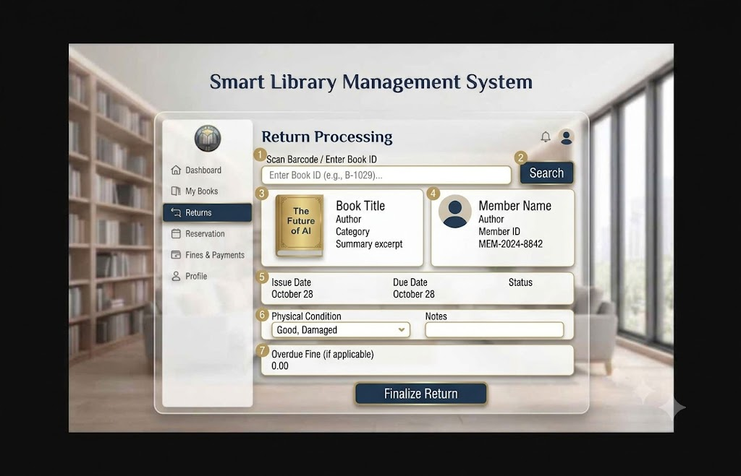
Figure 3.7: Book Return Page
- Controls: Book ID Input, Return Button, Fine Calculation Display
- Input Constraints: Book must be issued to the current user

return-book.php
<?php
session_start();

// Check if user is logged in
if (!isset($_SESSION['user_id'])) {
header("Location: login.php");
exit();
}

$errors = [];
$success_message = '';
$book_data = null;
$return_summary = null;

// Handle form submission
if ($_SERVER['REQUEST_METHOD'] === 'POST') {
$action = isset($_POST['action']) ? $_POST['action'] : '';

if ($action === 'search_book') {
$book_id = isset($_POST['book_id']) ? trim($_POST['book_id']) : '';

if (empty($book_id)) {
$errors[] = 'Please enter a Book ID or scan barcode';
} else {
// TODO: Fetch book data from database using book_id
// For now, simulate with sample data
$book_data = [
'book_id' => $book_id,
'isbn' => '978-0-375-50120-0',
'title' => 'The Future of AI',
'author' => 'Tech Author',
'category' => 'Technology',
'summary' => 'An insightful exploration into artificial intelligence and its impact on society.',
'cover' => 'https://via.placeholder.com/120x160?text=FutureAI',
'member_name' => 'John Alexandria',
'member_id' => 'MEM-2024-8842',
'issue_date' => '2024-10-28',
'due_date' => '2024-11-04',
'actual_return_date' => date('Y-m-d'),
'status' => 'On Loan',
'days_overdue' => 0,
'overdue_fine' => 0.00,
'issue_id' => 'ISS-2024-1234'
];

// Calculate days overdue
$today = new DateTime();
$due = new DateTime($book_data['due_date']);
if ($today > $due) {
$book_data['days_overdue'] = $today->diff($due)->days;
// Fine calculation: typically per day (e.g., $0.50 per day)
$book_data['overdue_fine'] = $book_data['days_overdue'] * 0.50;
}
}
}

elseif ($action === 'finalize_return') {
$book_id = isset($_POST['book_id_hidden']) ? trim($_POST['book_id_hidden']) : '';
$physical_condition = isset($_POST['physical_condition']) ? $_POST['physical_condition'] : '';
$notes = isset($_POST['notes']) ? trim($_POST['notes']) : '';

if (empty($book_id)) {
$errors[] = 'Invalid request. Please search for a book first.';
} elseif (empty($physical_condition)) {
$errors[] = 'Please select the physical condition of the book';
} else {
// TODO: Process return in database
// Update book status to available
// Add fine if overdue
// Create return transaction record

$success_message = "Book '{$book_data['title']}' has been successfully returned.";
if ($book_data['overdue_fine'] > 0) {
$success_message .= " Overdue fine: \$" . number_format($book_data['overdue_fine'], 2);
}

// Reset form
$book_data = null;
$return_summary = null;
}
}
}
?>

<!DOCTYPE html>
<html lang="en">
<head>
<meta charset="UTF-8">
<meta name="viewport" content="width=device-width, initial-scale=1.0">
<title>Return Book - Smart Library Management System</title>

<!-- Bootstrap CSS -->
<link href="https://cdn.jsdelivr.net/npm/bootstrap@5.3.0/dist/css/bootstrap.min.css" rel="stylesheet">

<!-- Font Awesome for icons -->
<link rel="stylesheet" href="https://cdnjs.cloudflare.com/ajax/libs/font-awesome/6.4.0/css/all.min.css">

<!-- Custom CSS -->
<link rel="stylesheet" href="css/return-book-style.css">
</head>
<body class="return-book-page">
<div class="container-fluid">
<div class="row min-vh-100">
<!-- Sidebar Navigation -->
<nav class="col-lg-3 col-xl-2 sidebar">
<div class="sidebar-header">
<div class="logo-circle mb-3">
<i class="fas fa-book"></i>
</div>
<h5 class="text-center fw-bold">Smart Library</h5>
</div>

<ul class="nav flex-column nav-menu">
<li class="nav-item">
<a class="nav-link" href="dashboard.php">
<i class="fas fa-home me-2"></i>
<span>Dashboard</span>
</a>
</li>
<li class="nav-item">
<a class="nav-link" href="my-books.php">
<i class="fas fa-book me-2"></i>
<span>My Books</span>
</a>
</li>
<li class="nav-item">
<a class="nav-link" href="search-catalog.php">
<i class="fas fa-search me-2"></i>
<span>Search Catalog</span>
</a>
</li>
<li class="nav-item">
<a class="nav-link" href="reservations.php">
<i class="fas fa-calendar me-2"></i>
<span>Reservation</span>
</a>
</li>
<li class="nav-item">
<a class="nav-link active" href="return-book.php">
<i class="fas fa-undo me-2"></i>
<span>Returns</span>
</a>
</li>
<li class="nav-item">
<a class="nav-link" href="fines-payments.php">
<i class="fas fa-receipt me-2"></i>
<span>Fines & Payments</span>
</a>
</li>
<li class="nav-item">
<a class="nav-link" href="profile.php">
<i class="fas fa-user me-2"></i>
<span>Profile</span>
</a>
</li>
</ul>

<!-- Logout Button -->
<div class="sidebar-footer">
<a href="dashboard.php?action=logout" class="btn btn-logout w-100">
<i class="fas fa-sign-out-alt me-2"></i>
Logout
</a>
</div>
</nav>

<!-- Main Content -->
<main class="col-lg-9 col-xl-10 content-area">
<!-- Header -->
<header class="page-header">
<div class="header-content">
<h1 class="mb-0">Return Processing</h1>
</div>
<div class="header-actions">
<button class="btn btn-icon notification-btn" title="Notifications">
<i class="fas fa-bell"></i>
<span class="badge">3</span>
</button>
<button class="btn btn-icon profile-btn" title="Profile">
<i class="fas fa-user-circle"></i>
</button>
</div>
</header>
<!-- Content -->
<div class="return-content">
<!-- Error Messages -->
<?php if (!empty($errors)): ?>
<div class="alert alert-danger alert-dismissible fade show" role="alert">
<i class="fas fa-exclamation-circle me-2"></i>
<strong>Error:</strong>
<ul class="mb-0 mt-2">
<?php foreach ($errors as $error): ?>
<li><?php echo htmlspecialchars($error); ?></li>
<?php endforeach; ?>
</ul>
<button type="button" class="btn-close" data-bs-dismiss="alert"></button>
</div>
<?php endif; ?>
<!-- Success Message -->
<?php if (!empty($success_message)): ?>
<div class="alert alert-success alert-dismissible fade show" role="alert">
<i class="fas fa-check-circle me-2"></i>
<?php echo htmlspecialchars($success_message); ?>
<button type="button" class="btn-close" data-bs-dismiss="alert"></button>
</div>
<?php endif; ?>
<div class="row g-4">
<!-- Step 1: Book Search -->
<div class="col-lg-12">
<div class="step-card">
<div class="step-number">1</div>
<div class="step-content">
<h5 class="step-title">Scan Barcode / Enter Book ID</h5>
<form method="POST" class="step-form" id="searchForm">
<input type="hidden" name="action" value="search_book">
<div class="form-group">
<label for="book_id" class="form-label">Enter Book ID (e.g., B-1029)</label>
<div class="input-group">
<input
type="text"
class="form-control"
id="book_id"
name="book_id"
placeholder="Enter Book ID or scan barcode..."
value="<?php echo htmlspecialchars($_POST['book_id'] ?? ''); ?>"
required
autofocus
>
<button type="submit" class="btn btn-search">
<i class="fas fa-search me-2"></i>Search
</button>
</div>
</div>
</form>
</div>
</div>
</div>
<!-- Step 2 & 3: Book Details -->
<?php if ($book_data): ?>
<div class="col-lg-6">
<div class="step-card">
<div class="step-number">3</div>
<div class="step-content">
<h5 class="step-title">Book Information</h5>
<div class="book-details">
<div class="book-cover mb-3">
<img src="<?php echo htmlspecialchars($book_data['cover']); ?>" alt="Book">
</div>
<div class="detail-row">
<label>Book Title</label>
<p><?php echo htmlspecialchars($book_data['title']); ?></p>
</div>
<div class="detail-row">
<label>Author</label>
<p><?php echo htmlspecialchars($book_data['author']); ?></p>
</div>
<div class="detail-row">
<label>Category</label>
<p><?php echo htmlspecialchars($book_data['category']); ?></p>
</div>
<div class="detail-row">
<label>Summary</label>
<p><?php echo htmlspecialchars($book_data['summary']); ?></p>
</div>
</div>
</div>
</div>
</div>
<!-- Step 4: Member Information -->
<div class="col-lg-6">
<div class="step-card">
<div class="step-number">4</div>
<div class="step-content">
<h5 class="step-title">Member Information</h5>
<div class="member-details">
<div class="detail-row">
<label>Member Name</label>
<p><?php echo htmlspecialchars($book_data['member_name']); ?></p>
</div>
<div class="detail-row">
<label>Member ID</label>
<p><?php echo htmlspecialchars($book_data['member_id']); ?></p>
</div>
<div class="detail-row">
<label>Status</label>
<p>
<span class="badge bg-primary">
<?php echo htmlspecialchars($book_data['status']); ?>
</span>
</p>
</div> </div> </div> </div> </div>
<!-- Step 5: Loan Details -->
<div class="col-lg-12">
<div class="step-card">
<div class="step-number">5</div>
<div class="step-content">
<h5 class="step-title">Loan Details</h5>
<div class="loan-details">
<div class="row">
<div class="col-md-4">
<div class="detail-row">
<label>Issue Date</label>
<p><?php echo date('F d, Y', strtotime($book_data['issue_date'])); ?></p>
</div>
</div>
<div class="col-md-4">
<div class="detail-row">
<label>Due Date</label>
<p><?php echo date('F d, Y', strtotime($book_data['due_date'])); ?></p>
</div>
</div>
<div class="col-md-4">
<div class="detail-row">
<label>Status</label>
<p>
<?php if ($book_data['days_overdue'] > 0): ?>
<span class="badge bg-danger">
<?php echo $book_data['days_overdue']; ?> days overdue
</span>
<?php else: ?>
<span class="badge bg-success">On Time</span>
<?php endif; ?>
</p>
</div> </div> </div> </div> </div> </div> </div>
<!-- Step 7: Overdue Fine -->
<div class="col-lg-12">
<div class="step-card">
<div class="step-number">7</div>
<div class="step-content">
<h5 class="step-title">Overdue Fine (if applicable)</h5>
<div class="fine-details">
<div class="fine-amount">
<label>Total Fine</label>
<p class="amount <?php echo $book_data['overdue_fine'] > 0 ? 'text-danger' : ''; ?>">
$<?php echo number_format($book_data['overdue_fine'], 2); ?>
</p>
</div>
<?php if ($book_data['overdue_fine'] > 0): ?>
<div class="fine-breakdown">
<p class="small text-muted">
<i class="fas fa-info-circle me-1"></i>
<?php echo $book_data['days_overdue']; ?> days overdue × $0.50/day = $<?php echo number_format($book_data['overdue_fine'], 2); ?>
</p>
</div>
<?php endif; ?>
</div> </div> </div> </div>
<!-- Return Form -->
<div class="col-lg-12">
<form method="POST" id="returnForm">
<input type="hidden" name="action" value="finalize_return">
<input type="hidden" name="book_id_hidden" value="<?php echo htmlspecialchars($book_data['book_id']); ?>">
<input type="hidden" name="physical_condition" id="physical_condition_hidden">
<input type="hidden" name="notes" id="notes_hidden">
</form>
<button type="button" class="btn btn-finalize w-100" onclick="finalizeReturn()">
<i class="fas fa-check-circle me-2"></i>Finalize Return
</button>
</div>
<?php endif; ?>
</div> </div> </main> </div> </div>
</body>
</html>

Manage Books (Admin)
Purpose:
This page allows Admins to Add New Book, Edit Book Record, Update book record and Delate book record in the Smart Library Management system.
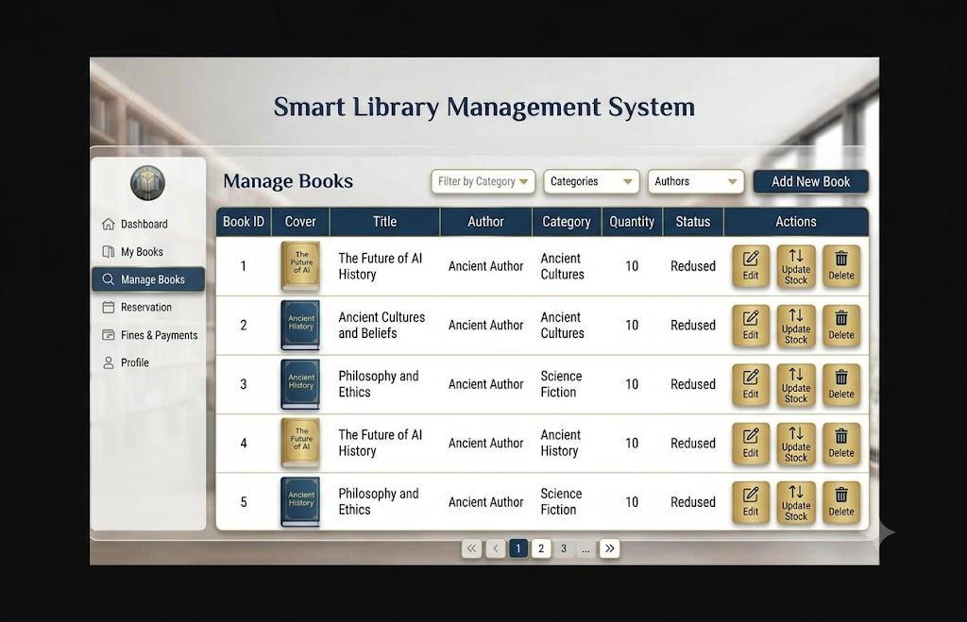
Figure 3.8: Manage Book Page
- Controls: Add New Book Form (Textboxes for Title, Author, ISBN, Publisher, Category, Quantity, Price), Data Table with Edit/Delete buttons
- Input Constraints: ISBN must be unique, Quantity must be positive integer

manage-books.php
<?php
session_start();
// Check if user is logged in and is admin
if (!isset($_SESSION['user_id']) || $_SESSION['user_role'] !== 'admin') {
header("Location: login.php");
exit();
}
$errors = [];
$success_message = '';
$current_page = isset($_GET['page']) ? (int)$_GET['page'] : 1;
$filter_category = isset($_GET['category']) ? $_GET['category'] : '';
$search_query = isset($_GET['search']) ? trim($_GET['search']) : '';
// TODO: Fetch books from database
// For now, simulate with sample data
$books = [
[
'id' => 1,
'isbn' => '978-0-375-50120-0',
'title' => 'The Future of AI History',
'author' => 'Ancient Author',
'category' => 'Ancient Cultures',
'quantity' => 10,
'available' => 8,
'status' => 'Reduced',
'cover' => 'https://via.placeholder.com/80x100?text=FutureAI'
],
[
'id' => 2,
'isbn' => '978-0-375-50121-7',
'title' => 'Ancient Cultures and Beliefs',
'author' => 'Ancient Author',
'category' => 'Ancient Cultures',
'quantity' => 10,
'available' => 9,
'status' => 'Reduced',
'cover' => 'https://via.placeholder.com/80x100?text=Ancient'
],
[
'id' => 3,
'isbn' => '978-0-375-50122-4',
'title' => 'Philosophy and Ethics',
'author' => 'Ancient Author',
'category' => 'Science Fiction',
'quantity' => 10,
'available' => 7,
'status' => 'Reduced',
'cover' => 'https://via.placeholder.com/80x100?text=Philosophy'
],
[
'id' => 4,
'isbn' => '978-0-375-50123-1',
'title' => 'The Future of AI History',
'author' => 'Ancient Author',
'category' => 'Ancient History',
'quantity' => 10,
'available' => 5,
'status' => 'Reduced',
'cover' => 'https://via.placeholder.com/80x100?text=Future'
],
[
'id' => 5,
'isbn' => '978-0-375-50124-8',
'title' => 'Philosophy and Ethics',
'author' => 'Ancient Author',
'category' => 'Science Fiction',
'quantity' => 10,
'available' => 6,
'status' => 'Reduced',
'cover' => 'https://via.placeholder.com/80x100?text=Ethics'
]
];
// Get unique categories
$categories = array_unique(array_column($books, 'category'));
$categories = array_values($categories);
// Get unique authors
$authors = array_unique(array_column($books, 'author'));
$authors = array_values($authors);
// Filter books
if ($filter_category) {
$books = array_filter($books, function($book) use ($filter_category) {
return $book['category'] === $filter_category;
});
}
if ($search_query) {
$books = array_filter($books, function($book) use ($search_query) {
$query = strtolower($search_query);
return strpos(strtolower($book['title']), $query) !== false ||
strpos(strtolower($book['author']), $query) !== false ||
strpos(strtolower($book['isbn']), $query) !== false;
});
}
// Pagination
$items_per_page = 10;
$total_books = count($books);
$total_pages = ceil($total_books / $items_per_page);
$current_page = min($current_page, $total_pages);
$start_index = ($current_page - 1) * $items_per_page;
$paginated_books = array_slice($books, $start_index, $items_per_page);
// Handle actions
<!DOCTYPE html>
<html lang="en">
<head>
<meta charset="UTF-8">
<meta name="viewport" content="width=device-width, initial-scale=1.0">
<title>Manage Books - Smart Library Management System</title>

<!-- Bootstrap CSS -->
<link href="https://cdn.jsdelivr.net/npm/bootstrap@5.3.0/dist/css/bootstrap.min.css" rel="stylesheet">
<!-- Logout Button -->
<div class="sidebar-footer">
<a href="login.php?action=logout" class="btn btn-logout w-100">
<i class="fas fa-sign-out-alt me-2"></i>
Logout
</a>
</div>
</nav>
<!-- Main Content -->
<main class="col-lg-9 col-xl-10 content-area">
<!-- Header -->
<header class="page-header">
<div class="header-content">
<h1 class="mb-0">Manage Books</h1>
</div>
<div class="header-actions">
<button class="btn btn-add-book" data-bs-toggle="modal" data-bs-target="#addBookModal">
<i class="fas fa-plus me-2"></i>Add New Book
</button>
</div>
</header>
<!-- Filters and Search -->
<div class="filters-section mb-4">
<div class="row g-3">
<div class="col-md-4">
<div class="search-box">
<input type="text" class="form-control" id="searchInput" placeholder="Search books, authors...">
<i class="fas fa-search search-icon"></i>
</div>
</div>
<div class="col-md-3">
<select class="form-select" id="categoryFilter">
<option value="">Filter by Category</option>
<?php foreach ($categories as $category): ?>
<option value="<?php echo htmlspecialchars($category); ?>"><?php echo htmlspecialchars($category); ?></option>
<?php endforeach; ?>
</select>
</div>
<div class="col-md-3">
<select class="form-select" id="authorFilter">
<option value="">All Authors</option>
<?php foreach ($authors as $author): ?>
<option value="<?php echo htmlspecialchars($author); ?>"><?php echo htmlspecialchars($author); ?></option>
<?php endforeach; ?>
</select>
</div>
<div class="col-md-2">
<button class="btn btn-filter w-100">
<i class="fas fa-search me-2"></i>Search
</button>
</div>
</div>
</div>
</div>
</div>
</body>
</html>

My Borrowed Books
Purpose:
This page shows users’ borrowed books list in the Smart Library Management system.
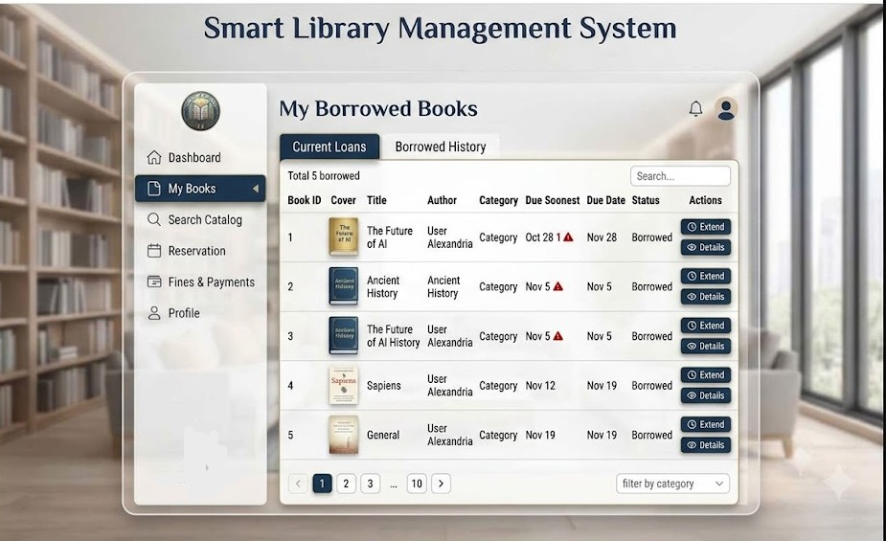
Figure 3.9: My Borrow Book Page
- Controls: filter by category, Details of book button
- Input Constraints: Search bar Input

my-books.php
<?php
session_start();

// Check if user is logged in
if (!isset($_SESSION['user_id'])) {
header("Location: login.php");
exit();
}

$user_id = $_SESSION['user_id'];
$tab = isset($_GET['tab']) ? $_GET['tab'] : 'current';
$current_page = isset($_GET['page']) ? (int)$_GET['page'] : 1;
$search_query = isset($_GET['search']) ? trim($_GET['search']) : '';
$filter_category = isset($_GET['category']) ? $_GET['category'] : '';

// TODO: Fetch user's borrowed books from database
// For now, simulate with sample data
// Get unique categories
$all_books = array_merge($current_loans, $borrowed_history);
$categories = array_unique(array_column($all_books, 'category'));
$categories = array_values($categories);

// Filter based on tab
$books_to_display = $tab === 'current' ? $current_loans : $borrowed_history;

// Apply filters
if ($search_query) {
$books_to_display = array_filter($books_to_display, function($book) use ($search_query) {
$query = strtolower($search_query);
return strpos(strtolower($book['title']), $query) !== false ||
strpos(strtolower($book['author']), $query) !== false;
});
}

if ($filter_category) {
$books_to_display = array_filter($books_to_display, function($book) use ($filter_category) {
return $book['category'] === $filter_category;
});
}

// Pagination
$items_per_page = 10;
$total_books = count($books_to_display);
$total_pages = ceil($total_books / $items_per_page);
$current_page = min($current_page, max(1, $total_pages));
$start_index = ($current_page - 1) * $items_per_page;
$paginated_books = array_slice($books_to_display, $start_index, $items_per_page);

// Count stats
$total_borrowed = count($current_loans);
$overdue_count = count(array_filter($current_loans, function($book) {
return $book['is_overdue'];
}));
?>

<!DOCTYPE html>
<html lang="en">
<head>
<meta charset="UTF-8">
<meta name="viewport" content="width=device-width, initial-scale=1.0">
<title>My Borrowed Books - Smart Library Management System</title>
<!-- Bootstrap CSS -->
<link href="https://cdn.jsdelivr.net/npm/bootstrap@5.3.0/dist/css/bootstrap.min.css" rel="stylesheet">
<!-- Font Awesome for icons -->
<link rel="stylesheet" href="https://cdnjs.cloudflare.com/ajax/libs/font-awesome/6.4.0/css/all.min.css">
<!-- Custom CSS -->
<link rel="stylesheet" href="css/my-books-style.css">
</head>
<body class="my-books-page">
<div class="container-fluid">
<div class="row min-vh-100">
<!-- Sidebar Navigation -->
<nav class="col-lg-3 col-xl-2 sidebar">
<div class="sidebar-header">
<div class="logo-circle mb-3">
<i class="fas fa-book"></i>
</div>
<h5 class="text-center fw-bold">Smart Library</h5>
</div>
<ul class="nav flex-column nav-menu">
<li class="nav-item">
<a class="nav-link" href="dashboard.php">
<i class="fas fa-home me-2"></i>
<span>Dashboard</span>
</a>
</li>
<li class="nav-item">
<a class="nav-link active" href="my-books.php">
<i class="fas fa-book me-2"></i>
<span>My Books</span>
</a>
</li>
<li class="nav-item">
<a class="nav-link" href="search-catalog.php">
<i class="fas fa-search me-2"></i>
<span>Search Catalog</span>
</a>
</li>
<li class="nav-item">
<a class="nav-link" href="reservations.php">
<i class="fas fa-calendar me-2"></i>
<span>Reservation</span>
</a>
</li>
<li class="nav-item">
<a class="nav-link" href="fines-payments.php">
<i class="fas fa-receipt me-2"></i>
<span>Fines & Payments</span>
</a>
</li>
<li class="nav-item">
<a class="nav-link" href="profile.php">
<i class="fas fa-user me-2"></i>
<span>Profile</span>
</a>
</li>
</ul>
<!-- Logout Button -->
<div class="sidebar-footer">
<a href="dashboard.php?action=logout" class="btn btn-logout w-100">
<i class="fas fa-sign-out-alt me-2"></i>
Logout
</a>
</div>
</nav>
<!-- Main Content -->
<main class="col-lg-9 col-xl-10 content-area">
<!-- Header -->
<header class="page-header">
<div class="header-content">
<h1 class="mb-0">My Borrowed Books</h1>
</div>
<div class="header-actions">
<button class="btn btn-icon notification-btn" title="Notifications">
<i class="fas fa-bell"></i>
<span class="badge">3</span>
</button>
<button class="btn btn-icon profile-btn" title="Profile">
<i class="fas fa-user-circle"></i>
</button>
</div>
</header>

<!-- Content -->
<div class="page-content">
<!-- Tab Navigation -->
<div class="books-tabs mb-4">
<ul class="nav nav-tabs" role="tablist">
<li class="nav-item" role="presentation">
<button class="nav-link <?php echo $tab === 'current' ? 'active' : ''; ?>"
onclick="switchTab('current')">
<i class="fas fa-hourglass-half me-2"></i>
Current Loans
<span class="badge bg-primary ms-2"><?php echo $total_borrowed; ?></span>
<?php if ($overdue_count > 0): ?>
<span class="badge bg-danger ms-1"><?php echo $overdue_count; ?></span>
<?php endif; ?>
</button>
</li>
<li class="nav-item" role="presentation">
<button class="nav-link <?php echo $tab === 'history' ? 'active' : ''; ?>"
onclick="switchTab('history')">
<i class="fas fa-history me-2"></i>
Borrowed History
</button>
</li>
</ul>
</div>
</div>
</body>
</html>

Defaulter List & Reports
Purpose:
This page shows list of Defaulters and Reports about users in the Smart Library Management system.
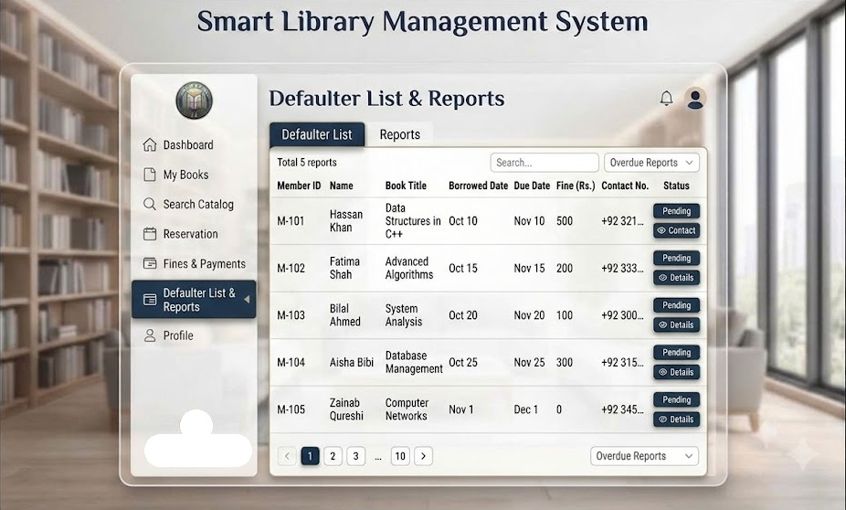
Figure 3.10: Defaulter Page

- Data Displayed: List of Defaulters with fine and Due Dates also name and contacts of defaulters.

defaulter-reports.php
<?php
session_start();

// Check if user is logged in and is admin
if (!isset($_SESSION['user_id']) || ($_SESSION['user_role'] !== 'admin' && $_SESSION['user_role'] !== 'librarian')) {
header("Location: login.php");
exit();
}

$tab = isset($_GET['tab']) ? $_GET['tab'] : 'defaulters';
$current_page = isset($_GET['page']) ? (int)$_GET['page'] : 1;
$search_query = isset($_GET['search']) ? trim($_GET['search']) : '';
$filter_status = isset($_GET['status']) ? $_GET['status'] : '';

// TODO: Fetch defaulter data from database
// For now, simulate with sample data

$reports_data = [
[
'report_id' => 'RPT-001',
'report_name' => 'Monthly Defaulter Report',
'generated_date' => '2024-12-06',
'total_defaulters' => 15,
'total_fine_pending' => 2500,
'generated_by' => 'System Admin',
'status' => 'Completed'
],
[
'report_id' => 'RPT-002',
'report_name' => 'Overdue Books Analysis',
'generated_date' => '2024-12-05',
'total_defaulters' => 12,
'total_fine_pending' => 1800,
'generated_by' => 'Librarian',
'status' => 'Completed'
],
[
'report_id' => 'RPT-003',
'report_name' => 'Member Fine Summary',
'generated_date' => '2024-12-04',
'total_defaulters' => 20,
'total_fine_pending' => 3200,
'generated_by' => 'System Admin',
'status' => 'Completed'
]
];
// Filter defaulters
$filtered_defaulters = $defaulters;
if ($search_query) {
$filtered_defaulters = array_filter($filtered_defaulters, function($defaulter) use ($search_query) {
$query = strtolower($search_query);
return strpos(strtolower($defaulter['member_id']), $query) !== false ||
strpos(strtolower($defaulter['name']), $query) !== false ||
strpos(strtolower($defaulter['book_title']), $query) !== false ||
strpos(strtolower($defaulter['email']), $query) !== false;
});
}
if ($filter_status && $filter_status !== 'All') {
$filtered_defaulters = array_filter($filtered_defaulters, function($defaulter) use ($filter_status) {
return $defaulter['status'] === $filter_status;
});
}
// Pagination
$items_per_page = 10;
$total_defaulters = count($filtered_defaulters);
$total_pages = ceil($total_defaulters / $items_per_page);
$current_page = min($current_page, max(1, $total_pages));
$start_index = ($current_page - 1) * $items_per_page;
$paginated_defaulters = array_slice($filtered_defaulters, $start_index, $items_per_page);
// Calculate statistics
$total_fine = array_sum(array_column($defaulters, 'fine_amount'));
$total_records = count($defaulters);
$critical_count = count(array_filter($defaulters, function($d) { return $d['days_overdue'] > 30; }));
// Handle actions
if ($_SERVER['REQUEST_METHOD'] === 'POST') {
$action = isset($_POST['action']) ? $_POST['action'] : '';
if ($action === 'send_reminder') {
$member_id = isset($_POST['member_id']) ? $_POST['member_id'] : '';
// TODO: Send email reminder
$success_message = "Reminder sent to member successfully.";
}
elseif ($action === 'mark_resolved') {
$member_id = isset($_POST['member_id']) ? $_POST['member_id'] : '';
// TODO: Update database
$success_message = "Member marked as resolved.";
}
}
?>
<!DOCTYPE html>
<html lang="en">
<head>
<meta charset="UTF-8">
<meta name="viewport" content="width=device-width, initial-scale=1.0">
<title>Defaulter List & Reports - Smart Library Management System</title>
<!-- Bootstrap CSS -->
<link href="https://cdn.jsdelivr.net/npm/bootstrap@5.3.0/dist/css/bootstrap.min.css" rel="stylesheet">
<!-- Font Awesome for icons -->
<link rel="stylesheet" href="https://cdnjs.cloudflare.com/ajax/libs/font-awesome/6.4.0/css/all.min.css">

</div> </div>
<!-- Bootstrap JS -->
<script src="https://cdn.jsdelivr.net/npm/bootstrap@5.3.0/dist/js/bootstrap.bundle.min.js"></script>
</body>
</html>

